**VIVEKANAND EDUCATION SOCIETY’S INSTITUTE OF TECHNOLOGY**

**(An Autonomous Institute Affiliated to University of Mumbai**

**Department of Computer Engineering)**

**Department of Computer Engineering**



**Project Report on**

# AI-Integrated Terminal

Submitted in partial fulfillment of the requirements of Third Year (Semester–VI), Bachelor of Engineering Degree in Computer Engineering at the University of Mumbai Academic Year 2024-25

By

**Aditi Dubey D12A/20**

**Riya Firke D12A/23**

**Nupur Pathare D12A/48**

**Parul Wanode D12A/66**

**Project Mentor**

Dr. Dashrath Mane

**University of Mumbai**

**(AY 2024-25)**

**VIVEKANAND EDUCATION SOCIETY’S INSTITUTE OF TECHNOLOGY**

**(An Autonomous Institute Affiliated to University of Mumbai**

**Department of Computer Engineering)**

**Department of Computer Engineering**



**CERTIFICATE**

This is to certify that **Aditi Dubey (20), Riya Firke (23), Nupur Pathare (48), Parul Wanode (66)** of Third Year Computer Engineering studying under the University of Mumbai has satisfactorily presented the project on “**AI Integrated Terminal**” as a part of the coursework of Mini Project 2B for Semester-VI under the guidance of Dr. Dashrath Mane in the year 2024-25.

______***_______________***

Date

| __________________ |  | __________________ |
| --- | --- | --- |
| Internal Examiner |  | External Examiner |

_________________ __________________ __________________

Project Mentor Head of the Department Principal

Dr. Dashrath Mane Dr. J. M. Nair Dr. Mrs. Nupur Giri

**Declaration**

We declare that this written submission represents our ideas in our own words and where others' ideas or words have been included, we have adequately cited and referenced the original sources. We also declare that we have adhered to all principles of academic honesty and integrity and have not misrepresented or fabricated or falsified any idea / data / fact / source in our submission. We understand that any violation of the above will be cause for disciplinary action by the Institute and can also evoke penal action from the sources which have thus not been properly cited or from whom proper permission has not been taken when needed.

| -----------------------------------------  (Signature)  -----------------------------------------  (Aditi Dubey / 20 ) | -----------------------------------------  (Signature)  -----------------------------------------  (Riya Firke / 23) |
| --- | --- |
| -----------------------------------------  (Signature)  -----------------------------------------  (Nupur Pathare / 48) | -----------------------------------------  (Signature)  -----------------------------------------  (Parul Wanode / 66) |

Date:

## ACKNOWLEDGEMENT

We are thankful to our college Vivekanand Education Society’s Institute of Technology for considering our project and extending help at all stages needed during our work of collecting information regarding the project.

It gives us immense pleasure to express our deep and sincere gratitude to Assistant Professor **Dr. (Mrs.) Priya R. L** (Project Guide) for her kind help and valuable advice during the development of project synopsis and for her guidance and suggestions.

We are deeply indebted to Head of the Computer Department **Dr.(Mrs.) Nupur Giri** and our Principal **Dr. (Mrs.) J.M. Nair ,** for giving us this valuable opportunity to do this project.

We express our hearty thanks to them for their assistance without which it would have been difficult in finishing this project synopsis and project review successfully.

We convey our deep sense of gratitude to all teaching and non-teaching staff for their constant encouragement, support and selfless help throughout the project work. It is a great pleasure to acknowledge the help and suggestion, which we received from the Department of Computer Engineering.

We wish to express our profound thanks to all those who helped us in gathering information about the project. Our families too have provided moral support and encouragement several times.

### Computer Engineering Department

**COURSE OUTCOMES FOR T.E MINI PROJECT 2B**

Learners will be to:-

| **CO No.** | **COURSE OUTCOME** |
| --- | --- |
| CO1 | Identify problems based on societal /research needs. |
| CO2 | Apply Knowledge and skill to solve societal problems in a group. |
| CO3 | Develop interpersonal skills to work as a member of a group or leader. |
| CO4 | Draw the proper inferences from available results through theoretical/ experimental/simulations. |
| CO5 | Analyze the impact of solutions in societal and environmental context for sustainable development. |
| CO6 | Use standard norms of engineering practices |
| CO7 | Excel in written and oral communication. |
| CO8 | Demonstrate capabilities of self-learning in a group, which leads to lifelong learning. |
| CO9 | Demonstrate project management principles during project work. |

**ABSTRACT**

This research presents the design and development of an AI-integrated terminal emulator that significantly enhances the usability and functionality of traditional command-line interfaces (CLIs). Conventional CLIs, while powerful, often demand high levels of memorization and command-line proficiency, creating barriers for novice users and inefficiencies for experienced ones. The proposed solution leverages machine learning—specifically the Random Forest algorithm—alongside natural language processing (NLP) to offer intelligent command predictions, real-time autocompletion, and contextual assistance. These features aim to reduce cognitive load, minimize syntax errors, and streamline user workflows.

Through a structured methodology, the team collected and preprocessed command data from Python, Java, and Linux environments, cleaning and formatting it for optimal training. After experimenting with several machine learning models, the Random Forest algorithm emerged as the most accurate, achieving 100% accuracy in command prediction during testing. The AI model was initially integrated into the VS Code terminal to evaluate performance and later embedded into a custom-built Python terminal. This terminal supports context-aware command suggestions, intelligent error detection, and learns from individual usage patterns to refine its outputs over time, thus offering a personalized and adaptive interface.

The paper also highlights the broader applicability of AI-enhanced CLI systems by referencing contemporary studies that demonstrate AI’s efficacy in command prediction, workload automation, and intelligent system monitoring. Technologies such as cloud-edge-terminal collaboration, contextual understanding, and predictive analytics are employed to transform the terminal experience from a static, text-based interaction into a dynamic, responsive environment. Furthermore, real-time feedback and integrated error handling ensure robust system performance, fostering greater accessibility and efficiency for developers and system administrators alike.

In conclusion, this AI-driven terminal represents a major step forward in the evolution of command-line tools. By unifying predictive machine learning techniques, intelligent feedback mechanisms, and adaptive learning models, the system modernizes terminal usage without sacrificing power or flexibility. It not only democratizes CLI use for novices but also boosts productivity for power users, marking a significant milestone in the convergence of artificial intelligence and software development tools.

**Index**

**Title page no.**

**Abstract**

**Chapter 1: Introduction**

1.1 Introduction

1.2 Motivation

1.3 Problem Definition

1.4 Existing Systems

1.5 Lacuna of the existing systems

1.6 Relevance of the Project

**Chapter 2: Literature Survey**

A. Overview of Literature Survey

B. Related Works

2.1 Research Papers Referred

a. Abstract of the research paper

b. Inference drawn

2.2 Patent search

2.3. Inference drawn

2.4 Comparison with the existing system

**Chapter 3: Requirement Gathering for the Proposed System**

3.1 Introduction to requirement gathering

3.2 Functional Requirements

3.3 Non-Functional Requirements

3.4.Hardware, Software , Technology and tools utilized

3.5 Constraints

**Chapter** 4**: Proposed Design**

4.1 Block diagram of the system

4.2 Modular design of the system

4.3 Detailed Design

4.4 Project Scheduling & Tracking : Gantt Chart

**Chapter 5: Implementation of the Proposed System**

5.1. Methodology Employed

5.2 Algorithms and flowcharts

5.3 Dataset Description

**Chapter 6: Testing of the Proposed System**

6.1. Introduction to testing

6.2. Types of tests Considered

6.3 Various test case scenarios considered

6.4. Inference drawn from the test cases

**Chapter 7: Results and Discussion**

7.1. Screenshots of User Interface (GUI)

7.2. Performance Evaluation measures

7.3. Input Parameters / Features considered

7.4. Graphical and statistical output

7.5. Comparison of results with existing systems

7.6. Inference drawn

**Chapter 8: Conclusion**

8.1 Limitations

8.2 Conclusion

8.3 Future Scope

**References**

1. **Introduction**

**1.1 Introduction**

Command-line interfaces (CLIs) are fundamental tools in software development and system administration, providing direct and efficient access to system functionalities. However, CLIs often present a steep learning curve because they require users to memorize complex commands and syntax. This memorization can lead to inefficiencies and errors, posing challenges for both novice and experienced users. Enhancing the usability of CLIs is essential to improve productivity and accessibility across various user groups. Traditional terminal emulators, while powerful, can be intimidating and inefficient, highlighting the need for intelligent enhancements to simplify interactions without sacrificing functionality. This research introduces an AI-integrated terminal that uses machine learning and natural language processing to provide intelligent command suggestions and autocompletion.

**1.2 Motivation**

The primary motivation behind this research is to address the inefficiencies and difficulties associated with traditional CLIs. These inefficiencies stem from the need for users to memorize complex commands and syntax, which can lead to errors and a steep learning curve. By developing an AI-integrated terminal, the authors aim to reduce cognitive load, minimize errors, and optimize workflows, thereby enhancing user productivity and accessibility.

**1.3 Problem Definition**

The core problem addressed in this paper is the inefficiency and complexity of traditional CLIs. These interfaces require users to memorize a large number of commands and their syntax, leading to potential errors and a steep learning curve, hindering productivity and accessibility. The challenge is to develop a system that can simplify command-line interactions, reduce the burden on users, and improve overall efficiency without compromising the power and flexibility of CLIs.

**1.4 Existing Systems**

Existing systems primarily consist of traditional terminal emulators. These emulators provide a text-based interface for interacting with the operating system, allowing users to execute commands and manage files. While powerful, they rely on manual input and memorization, which can be inefficient and error-prone.

**1.5 Lacuna of the Existing Systems**

Traditional terminal emulators face several significant limitations that hinder user efficiency and accessibility. One major issue is the steep learning curve; users are often required to memorize complex commands and syntax, making it difficult for beginners to get started. This reliance on manual input can be both time-consuming and error-prone, increasing the chances of mistakes during usage. Additionally, the high cognitive load involved in recalling command options and their correct usage can overwhelm users, especially when working on complex tasks.

Traditional terminals also offer limited real-time assistance and error correction, providing little support to users when they make mistakes. The lack of predictive assistance means there are no AI-driven text completions or command suggestions, which could otherwise speed up typing and reduce errors. Moreover, these emulators exhibit limited context awareness; they do not adapt to the user's current directory, task, or usage patterns, resulting in a less intuitive and less efficient experience.

Another drawback is poor error handling. When errors occur, terminals often display cryptic messages that are difficult to understand or fix without extensive prior knowledge. This not only slows down the workflow but can also discourage users from exploring more advanced functionality. Overall, the traditional terminal’s rigid and outdated interface limits its usability, especially in an era where intelligent and user-friendly tools are becoming the norm.

**1.6 Relevance of the Project**

This project is highly relevant as it tackles the pressing need to improve the usability and efficiency of command-line interfaces (CLIs). By integrating artificial intelligence into the system, it aims to significantly enhance the user experience across multiple dimensions. One of the primary benefits is improved productivity, as AI can reduce the time and effort required to execute commands by offering intelligent suggestions and automation. It also increases accessibility, making CLIs more approachable and user-friendly for both novices and experienced users, bridging the gap between technical complexity and ease of use.

Furthermore, the system helps reduce errors by minimizing syntax-related mistakes and providing real-time corrective feedback, thereby lowering the barrier to entry and enhancing user confidence. In addition, it streamlines workflows through automation of common command sequences and context-aware recommendations, enabling users to work more efficiently and intuitively. Overall, the integration of AI into terminal environments presents a transformative step forward in modernizing CLIs to meet the evolving needs of today’s users.

**2: Literature Survey**

**A. Overview of Literature Survey**

The literature survey focuses on the role of artificial intelligence (AI) in enhancing command-line interfaces (CLIs). It explores how AI technologies, such as predictive text, error correction, and real-time assistance, can be integrated into CLIs to improve usability and efficiency. The survey also covers AI applications in related fields, such as logistics and IT management, to draw insights on optimizing CLI environments.

**2.1 Research Papers Referred**

**a. Abstract of the research paper**

* MacInnis et al. (2022): This research discusses the implementation of AI-driven auto completion systems in CLIs, enhancing usability by offering real-time command suggestions.
* Jain et al. (2019): This paper explores the integration of AI-based natural language processing models into terminal bots to automate command execution and reduce manual input.
* Tsolakis et al. (2022): This study investigates the role of AI in optimizing logistics operations in container port terminals, providing insights into AI's potential for improving operational efficiency in complex systems.
* Wang et al. (2024): This research explores AI-based situational awareness in IT terminals, focusing on global monitoring systems that use predictive analytics for enhanced decision-making.
* Li et al. (2016): This paper proposes a human-computer interactive method that enhances CLIs by incorporating AI-powered contextual understanding to tailor command recommendations.

**b. Inference drawn**

* The research by MacInnis et al. (2022) highlights the importance of AI-driven autocompletion in improving CLI usability by providing real-time command suggestions and reducing cognitive load.
* Jain et al. (2019) demonstrate the potential of AI-based natural language processing models to automate command execution and enhance user interactions in CLIs.
* Tsolakis et al. (2022) suggest that AI can optimize operations in complex systems, and similar AI-driven optimization techniques can be applied to CLIs to enhance resource allocation and automate workload distribution.
* Wang et al. (2024) emphasize the role of AI in enhancing decision-making in IT terminals through global monitoring systems and predictive analytics, which is crucial for ensuring robust CLI performance.
* Li et al. (2016) indicate that AI-powered contextual understanding can significantly improve the accuracy and efficiency of command recommendations in CLIs.

**2.2 Patent search**

The literature survey includes a reference to a U.S. Patent Application by Li et al. (2016), which proposes a human-computer interactive method based on artificial intelligence and terminal devices.

### 2.3 Inference Drawn

### The patent by Li et al. (2016) represents a significant milestone in the evolution of command-line interface (CLI) technology, especially in the context of artificial intelligence integration. The core idea inferred from this work is that there is a growing industry and research trend focused on enhancing terminal environments using AI technologies to make them more adaptive, responsive, and intelligent.

Traditionally, command-line environments have relied heavily on the user’s technical expertise, memorization of syntax, and command structure. Li et al. address these limitations by proposing an AI-driven model capable of learning from user inputs, understanding context, and offering real-time assistance through features like:

* Contextual command suggestions based on usage history and task patterns
* Intelligent error detection and correction of malformed commands
* Predictive typing and autocompletion, reducing the need for users to type lengthy commands
* Natural language understanding (NLU) to interpret loosely-structured or conversational input

The inference here is that AI can bridge the usability gap that exists in conventional CLIs, thereby democratizing access to terminal-based tools even for users with limited technical proficiency. This also highlights the potential for increased productivity, reduced user frustration, and faster task execution within complex software systems and development environments.

Furthermore, the use of machine learning and NLP (Natural Language Processing) in this context reflects a shift towards making developer tools more intuitive and human-centric, signaling a future where terminals could understand intent rather than just syntax.

### 2.4 Comparison with the Existing System

Traditional command-line interfaces, such as Bash, CMD, or PowerShell, operate in a fundamentally syntax-driven manner. While they are powerful and flexible, they lack intelligent assistance, and their usability often becomes a barrier for less-experienced users. Below is a comparison between the traditional systems and the proposed AI-enhanced CLI, across multiple dimensions:

| Feature | Traditional CLI | Proposed AI-Enhanced CLI |
| --- | --- | --- |
| Command Suggestion | Basic history-based auto-complete (e.g., using TAB) | Predictive suggestions using context and previous usage patterns |
| Error Handling | Syntax errors shown, but no suggestions provided | Real-time error detection, correction hints, and auto-correction |
| Natural Language Input | Not supported; requires strict syntax | Supports natural language commands using NLP models |
| User Assistance | Manual lookup or external help commands needed (e.g., man, --help) | Embedded, real-time help and guidance through AI |
| Learning Curve | Steep, especially for new users | Reduced learning curve due to human-like interactions |
| Task Automation | Possible but needs scripting knowledge | AI can infer intent and automate recurring commands or tasks |
| Adaptability | Static interface; does not learn from user | Continuously learns and adapts to user preferences and behavior |

**3: Requirement Gathering for the Proposed System**

**3.1 Introduction to requirement gathering**

Requirement gathering is a crucial step in the development process, involving the identification and documentation of the system's functional and non-functional requirements. This process ensures that the system meets the needs of its users and stakeholders.

**3.2 Functional Requirements**

Functional requirements define the specific actions that the system must perform. The functional requirements for the AI-integrated terminal include:

* Command Prediction and Autocompletion: The system should predict and autocomplete commands based on partial input, previous commands, and system context.
* Error Detection and Correction: The system should detect and correct syntax errors in real-time.
* Context-Aware Suggestions: The system should provide command suggestions based on the current working directory, recent command history, and file types.
* Command Grouping and Shortcuts: The system should suggest frequently used command sequences and provide context-aware shortcuts.
* User Input Processing: The system must accurately parse and interpret user commands.
* Output Generation: The system should generate appropriate responses, including command completions and error messages.

**3.3 Non-Functional Requirements**

Non-functional requirements define the quality attributes of the system. The non-functional requirements for the AI-integrated terminal include:

* Performance: The system should provide real-time command suggestions and autocompletion with minimal latency.
* Accuracy: The system should provide accurate and reliable command predictions.
* Usability: The system should be user-friendly and intuitive.
* Adaptability: The system should adapt to user behavior and refine suggestions over time.
* Efficiency: The system should efficiently manage resources and minimize processing overhead.
* Seamless Integration: The system should integrate seamlessly with existing shell environments.

**3.4 Hardware, Software, Technology, and Tools Utilized**

* Programming Language: Python was used for implementing the AI system.
* Machine Learning Algorithm: The Random Forest algorithm was used for command prediction.
* Terminal Development: Initially, the terminal was built using Rust, but later transitioned to Python for AI integration. PyQt5 was used for initial GUI development.
* Development Environment: VS Code was used for testing the model and integrating it into a real-world coding environment.
* Data Sources: Command datasets were collected from various repositories, including Python, Java, and Linux command histories.

**3.5 Constraints**

* Data Availability: The accuracy of the system depends on the availability and quality of training data.
* Computational Resources: Real-time command prediction requires sufficient computational resources.
* Integration Complexity: Integrating the AI system seamlessly with different shell environments can be challenging.
* Adaptability Limitations: While the system adapts to user behavior, there might be limitations in handling completely novel or rare commands.

**4: Proposed Design**

**4.1 Block diagram of the system**

The general framework architecture of the AI-integrated command-line terminal is illustrated in Figure 1. The system comprises the following key components:

* User Interface: The interface through which users interact with the terminal.
* Command Parser: This component parses and interprets user commands.
* AI Engine: The core of the system, which includes:  
  + NLP Model: Natural Language Processing Model
  + ML Models: Machine Learning Models (Random Forest Classifier)
  + Pre-processing Module: Handles data preprocessing tasks.
* Command Executor: Executes the interpreted commands.
* Output Generator: Generates responses, including command autocompletion.

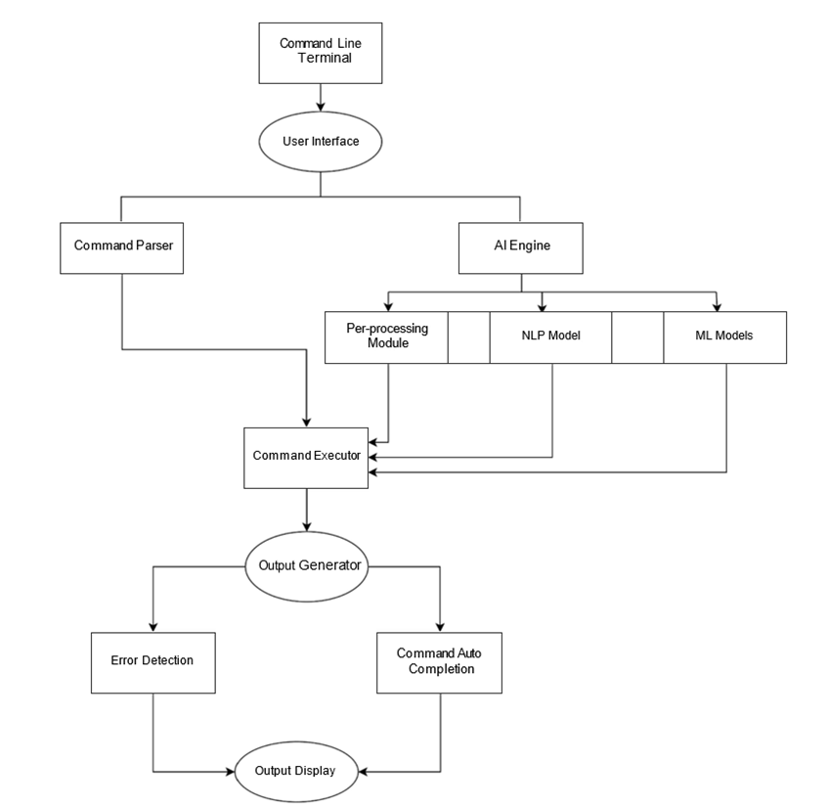

*Fig 1: Block Diagram*

**4.2 Modular design of the system**

The system is designed with a modular architecture to facilitate development, maintenance, and scalability. The main modules include:

* User Interface Module: Handles user input and output.
* Command Processing Module: Parses, interprets, and executes commands.
* AI Module: Implements the machine learning algorithms for command prediction and autocompletion.
* Error Handling Module: Detects and manages errors.
* Output Management Module: Formats and displays the output.

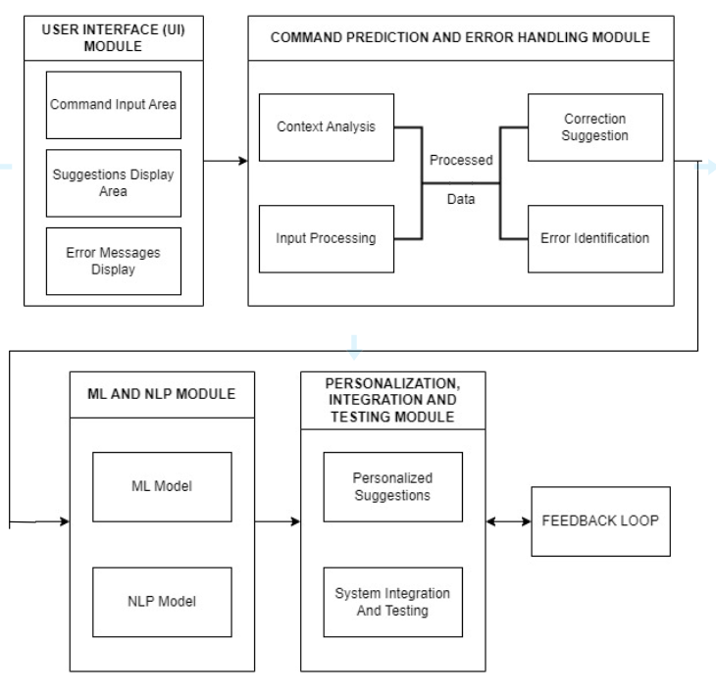

*Fig 2: Modular Diagram*

**4.3 Detailed Design**

The detailed design involves the following key aspects:

* Data Flow: User input is received by the User Interface, passed to the Command Parser, processed by the AI Engine, executed, and the output is generated and displayed.
* Algorithm Implementation: The Random Forest Classifier is trained on historical command-line interactions to predict and autocomplete commands.
* User Interface Design: The terminal interface is designed to be user-friendly and provide real-time AI-driven suggestions.

**5: Implementation of the Proposed System**

**5.1 Methodology Employed**

The implementation of the AI-driven terminal emulator involved a phased approach:

1. Initial Terminal Development: The terminal was initially built using Rust, focusing on performance and system efficiency.
2. Transition to Python: Due to challenges in integrating machine learning models directly within Rust, the project transitioned to Python for implementing the AI system.
3. Supervised Learning Model: A supervised learning model, specifically a Random Forest Classifier, was trained on historical command-line interactions.
4. Input Processing: User inputs (partial or complete commands) were converted into numerical representations using a vectorizer.
5. Model Training and Evaluation: The dataset was split into training and testing sets, and the Random Forest Classifier's performance was evaluated.
6. Real-time Integration: The AI system was integrated to process user inputs in real-time, providing dynamic and context-aware suggestions.
7. Event-Driven Architecture: The terminal employs an event-driven architecture to ensure high efficiency.
8. GUI Development: The graphical user interface (GUI) was initially developed using PyQt5.
9. VS Code Integration: The system was later embedded into the VS Code terminal to provide real-time command prediction and error detection within a coding environment.

**5.2 Algorithms and Flowcharts**

* Random Forest Classifier: The primary algorithm used for command prediction. It was chosen for its superior performance, achieving 100% model accuracy during testing.
* The paper includes a General Framework Architecture diagram (Fig. 1) that can be considered a high-level flowchart of the system's operation.

This flowchart (Fig 3) illustrates the workflow of an AI-integrated terminal system that enhances the command-line interface by offering intelligent command suggestions. The process begins when the user opens the terminal and inputs a command. The system then interprets the input to understand the command structure. At this point, the AI model checks if it can provide a suitable suggestion based on previous command patterns and user behavior. If no suggestion is available, the system executes the original command directly and displays the result to the user.

If the AI model does provide a suggestion, the user is given the option to select the customized command. Upon confirmation, the system executes the suggested command instead of the original one. The corresponding output is then displayed in the terminal. Whether the original or AI-suggested command is used, the system concludes the interaction by marking the project as completed. This intelligent workflow helps streamline the command-line experience by reducing errors, improving efficiency, and allowing users to leverage AI assistance seamlessly within a familiar terminal interface.

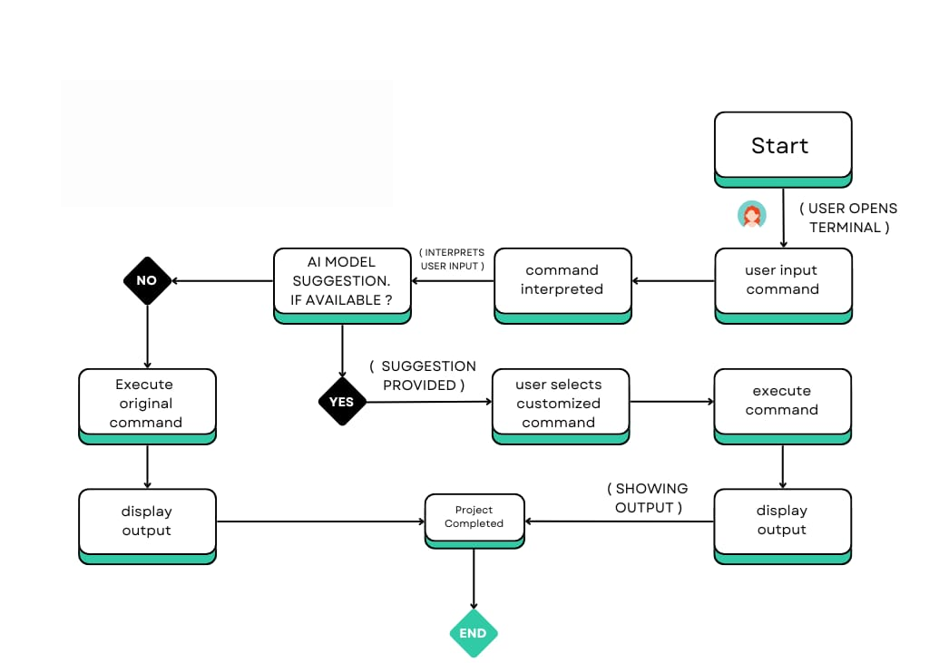

*Fig 3: Flowchart*

**5.3 Dataset Description**

Command datasets were collected from a variety of repositories, including Python, Java, and Linux command histories, to ensure a diverse and representative sample of real-world command-line usage. These datasets included frequently used commands, common command sequences, and user interactions across different CLI environments. To maintain data quality and consistency, several preprocessing steps were applied. This included data cleaning to remove duplicates and commands with incorrect syntax, data reduction to filter out infrequent or irrelevant commands, data merging to integrate datasets from multiple sources, and data formatting to standardize command structures for uniform analysis and model training. These steps ensured the resulting dataset was both clean and structured, providing a solid foundation for developing intelligent CLI enhancements.

This comprehensive preprocessing not only improved the reliability of the data but also enhanced the system’s ability to learn meaningful patterns from real user behavior. By leveraging this refined dataset, the project ensures that the AI-driven features—such as command suggestions, error correction, and automation—are grounded in practical usage scenarios, ultimately resulting in a smarter and more responsive command-line experience.

**Chapter 6: Testing of the Proposed System**

**6.1 Introduction to testing**

Testing is a critical phase to ensure the accuracy, efficiency, and usability of the AI-integrated terminal. It involves validating the system's performance under various conditions and identifying potential issues.

**6.2 Types of tests considered**

The paper mentions testing the model in the VS Code terminal to assess its command prediction and autocompletion capabilities. The AI-integrated terminal was also extensively tested for accuracy, efficiency, and usability.

**6.3 Various test case scenarios considered**

The paper highlights testing the system for:

* Seamless autocompletion: Ensuring commands are completed accurately and efficiently.
* Minimal errors: Validating that the system minimizes errors during command prediction and execution.
* Adaptability to user input patterns: Confirming that the system adapts to and learns from user behavior.
* Executing Python scripts: Testing the terminal's ability to handle script executions and provide relevant suggestions.

**6.4 Inference drawn from the test cases**

* The testing confirmed the model's ability to provide intelligent suggestions and accurate command completion.
* The AI-integrated terminal demonstrated seamless autocompletion, minimal errors, and adaptability to user input patterns.
* The system enhances workflow efficiency by reducing syntax errors and ensuring seamless execution of scripts.

**Chapter 7: Results and Discussion**

**7.1 Screenshots of User Interface (GUI)**

The AI-Integrated Terminal offers a sleek, dark-themed, frameless design that runs Windows CMD commands and shows system info instantly. It includes a right-side panel, "Ur AI Assistant is Here", for smart, AI-powered command help, and a handy "Search a command" button for quick suggestions. Its clean, modern layout makes it easy and efficient to use.

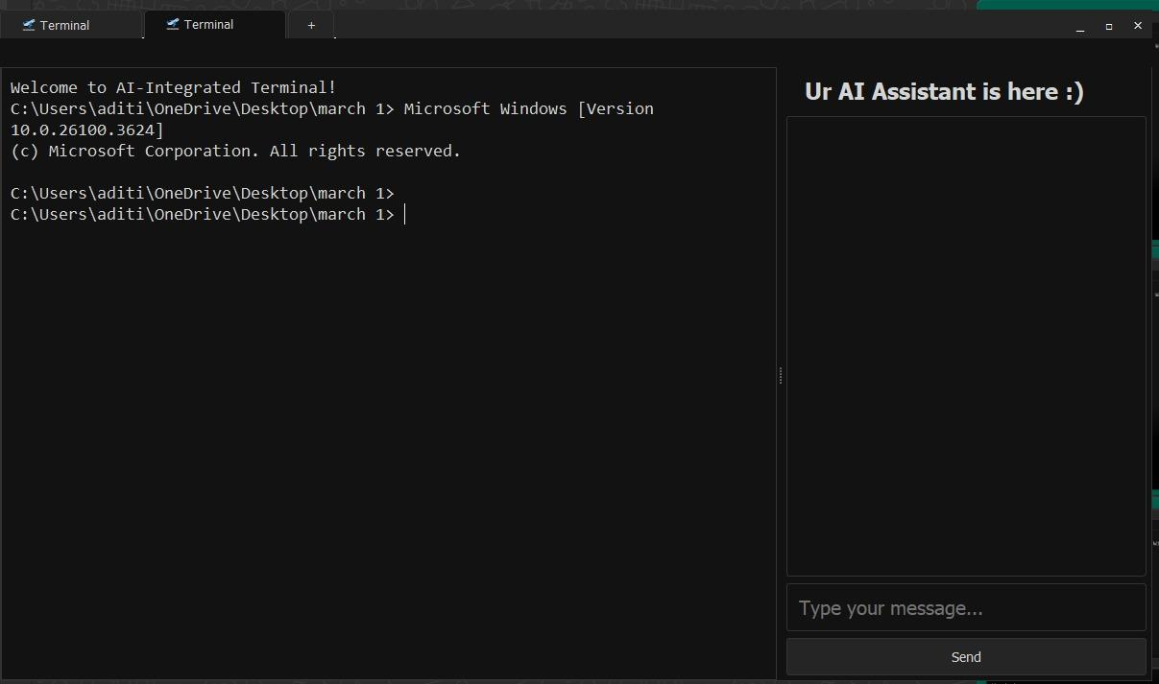

*Fig 4: Terminal Interface : Basic GUI of Terminal*

The AI-Integrated Terminal features a dark-themed interface with support for executing Windows CMD commands and displaying system details. It offers AI-powered command suggestions through a convenient dropdown list, along with a "Search a command" button to boost usability. Designed with a minimalistic and modern approach, it ensures smooth and intuitive interaction.

In addition to these features, the terminal includes an AI assistant panel on the right side, labeled “Ur AI Assistant is here :)”, providing a friendly and interactive space for users to engage with the assistant in natural language. This component enhances user support by allowing real-time queries, clarifications, or additional help beyond command suggestions. The clear separation between command execution and AI interaction ensures a distraction-free interface, while also empowering users to learn and explore commands more effectively. This design caters to both beginners seeking assistance and advanced users looking to optimize their workflow.

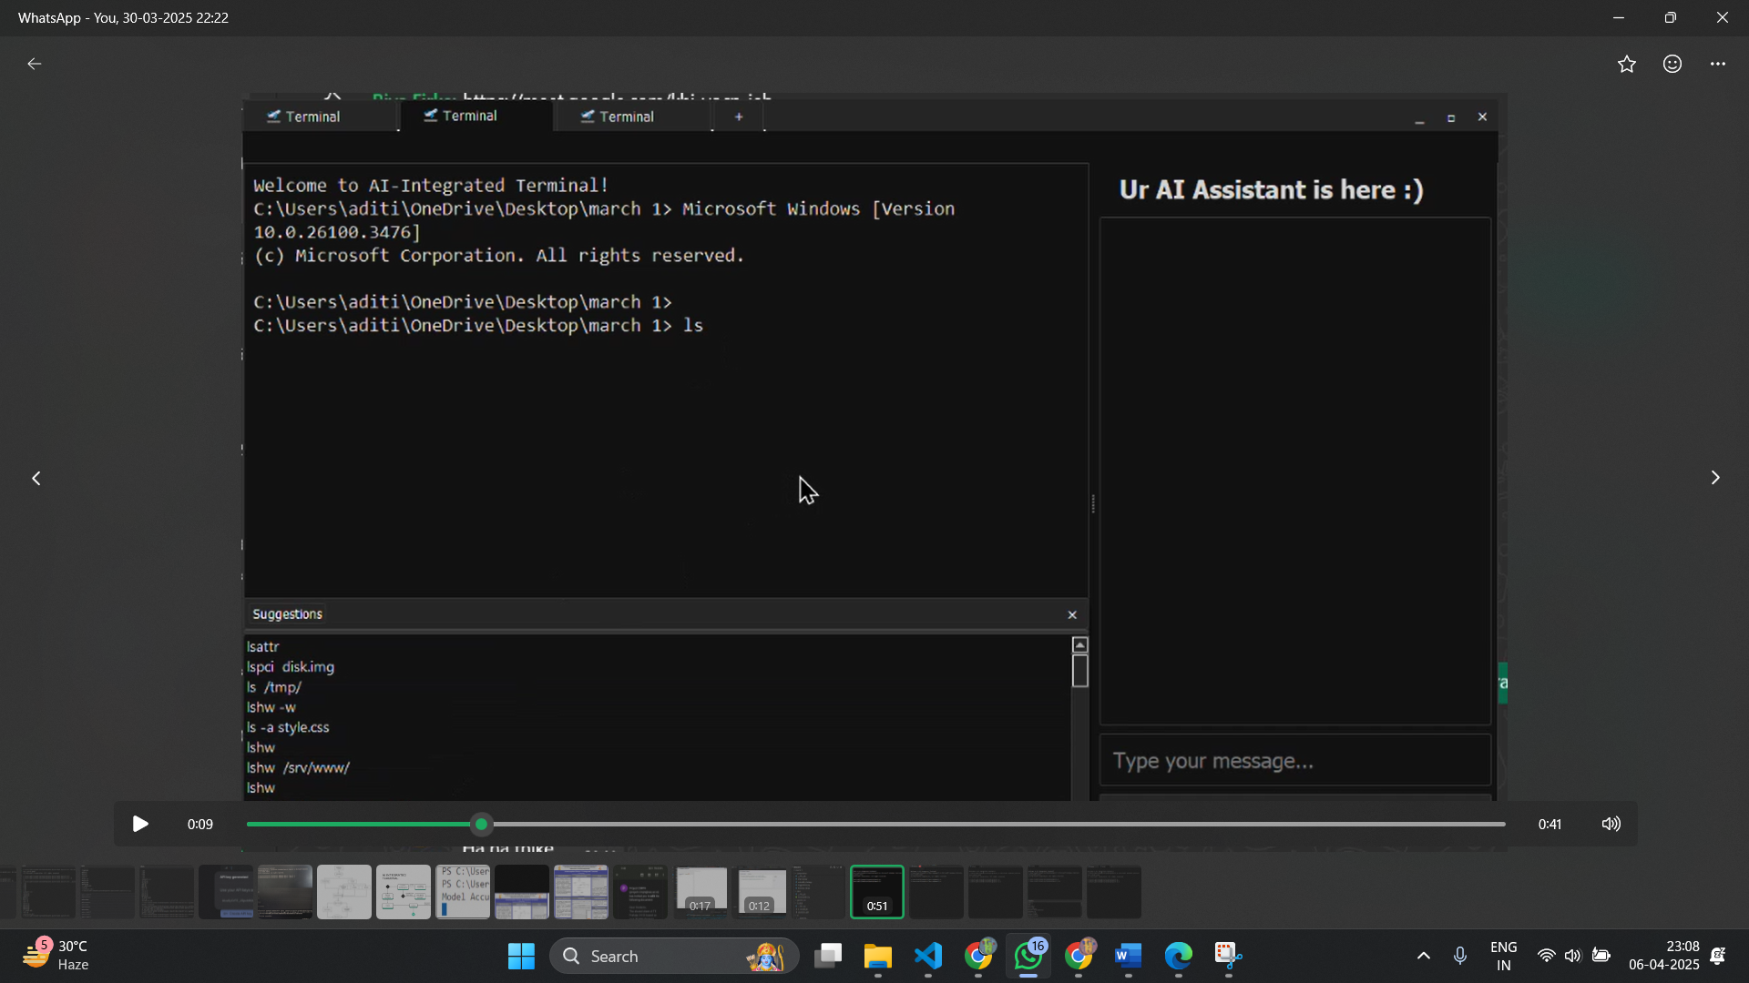

*Fig 5: Auto Completion: Predictive Suggestion list shown*

The AI-Powered Terminal integrates Google Gemini to deliver real-time command suggestions and coding assistance. It enhances user experience by offering instant support for terminal commands, Python scripting, and environment setup. With context-aware responses, it understands user inputs and provides accurate, relevant solutions directly within the terminal.

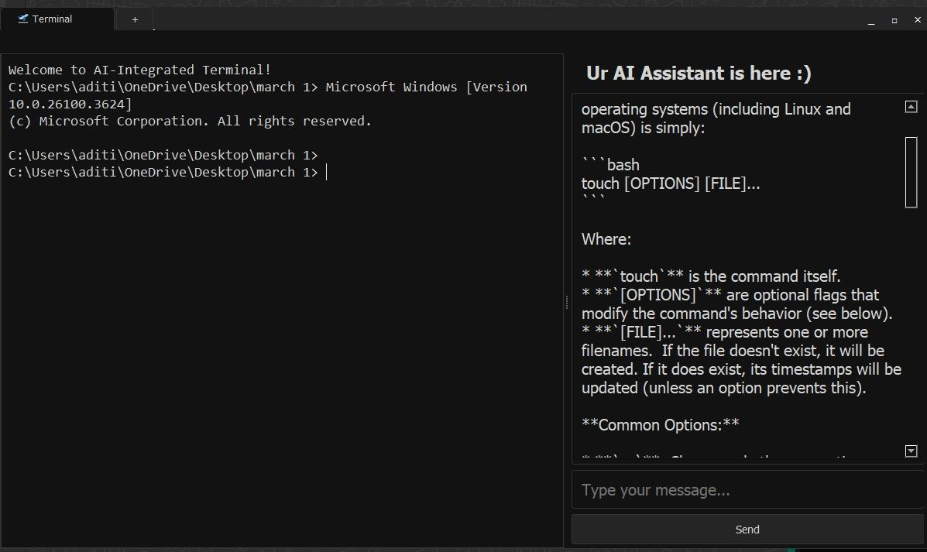

*Fig 6: AI Assistant: Gemini model integration.*

**7.2 Performance Evaluation measures**

* The primary performance evaluation measure reported is the model accuracy, which reached 100% during testing for the Random Forest Classifier.
* The system's efficiency is also evaluated in terms of its ability to provide real-time, context-aware suggestions and reduce typing effort and error rates.

**7.3 Input Parameters / Features considered**

The AI system takes into account several key input parameters to deliver accurate and context-aware suggestions. These include partial user input, which allows the system to predict and auto-complete commands as they are being typed, as well as previous commands to understand the user's typical usage patterns. It also considers the current system context and the working directory, ensuring that recommendations are relevant to the specific environment in which the user is operating. Additionally, the system leverages recent command history and the types of files present in the directory to provide more precise and useful suggestions. By incorporating these diverse inputs, the AI enhances the overall efficiency and intuitiveness of the command-line experience.

**7.4 Graphical and statistical output**

* The paper primarily presents screenshots of the user interface to demonstrate the system's functionality (Figs. 4, 5, and 6).
* The key statistical output is the 100% accuracy of the Random Forest Classifier.

**7.5 Comparison of results with existing systems**

* The paper emphasizes that the AI-integrated terminal enhances traditional CLIs by providing intelligent command suggestions, reducing typing effort, minimizing errors, and improving overall efficiency.
* Unlike existing systems that rely on memorization and manual input, the proposed system adapts to user behavior, provides context-aware assistance, and streamlines workflows.

**7.6 Inference drawn**

* The results indicate that the AI-integrated terminal significantly improves the user experience by making command-line interactions more intuitive and efficient.
* The system's ability to provide real-time suggestions, reduce errors, and adapt to user behavior demonstrates the potential of AI to modernize and enhance CLI environments.

**8: Conclusion**

**8.1 Limitations**

While the paper doesn't explicitly list limitations in a dedicated section, some potential limitations can be inferred:

* Data Dependency: The system's performance relies on the quality and quantity of training data.
* Computational Overhead: Real-time AI processing might introduce some computational overhead.
* Generalizability: The model's adaptability might be limited to the types of commands and patterns present in the training data.
* Complexity: Integrating AI into existing terminal environments can be complex.

**8.2 Conclusion**

The AI-integrated terminal emulator represents a significant leap forward in how users interact with command-line environments by seamlessly blending traditional functionalities with modern artificial intelligence technologies. Leveraging machine learning algorithms and natural language processing (NLP), this advanced system transforms the terminal from a rigid, syntax-dependent tool into a more dynamic and user-centric interface. One of its key innovations is predictive command suggestion, which intelligently anticipates user inputs based on command history, system context, and usage patterns. This not only accelerates command entry but also reduces the likelihood of syntax errors.

For novice users, these features drastically lower the barrier to entry, enabling them to interact with the terminal using more natural, conversational inputs without needing extensive prior knowledge of command syntax. For seasoned professionals, the system serves as a powerful productivity tool, automating routine tasks, suggesting optimizations, and improving overall command-line efficiency. Ultimately, the AI-integrated terminal emulator not only modernizes the command-line interface but also redefines it as an intelligent, responsive, and highly adaptive environment that caters to users of all skill levels.

**8.3 Future Scope**

The Cloud-Based Memory Manager plays a key role by fetching terminal history in real-time and providing up-to-date, relevant command recommendations. This feature ensures that users receive context-aware suggestions based on their previous interactions, significantly enhancing efficiency and usability. By continuously learning from user behavior, it helps create a more adaptive and responsive CLI environment tailored to individual workflows.

This research establishes a foundational framework for advancing intelligent automation and promoting user-centric computing within CLI environments. Through the integration of adaptive technologies and machine learning-driven processes, it enables more intuitive, efficient, and personalized user interactions. This paves the way for transforming traditional text-based interfaces into intelligent, context-aware systems that can anticipate user needs, streamline command executions, and reduce cognitive effort. Ultimately, the study not only drives the evolution of CLI tools but also sets a strong foundation for future innovations in seamless human-computer interaction.

**References**

[1] M. MacInnis, O. Baysal, and M. Lanza, "Terminals all the way down," *Proceedings of the ACM/IEEE 44th International Conference on Software Engineering (ICSE)*, 2022.

[2] N. Tsolakis, D. Zissis, S. Papaefthimiou, and A. Lagopoulos, "Towards AI-driven environmental sustainability: An application of automated logistics in container port terminals," *International Journal of Production Research*, 2022.

[3] Y. Wang, H. Hu, Y. Chen, Z. Chen, and Z. Li, "AI-based global situational awareness system design and application for IT terminals," *Proceedings of the 2024 8th [Conference Name]*, 2024.

[4] S. Jain, S. Sharma, and R. Tomar, "Integration of Wit API with Python-coded terminal bot," *Emerging Technologies in Data Mining and Information Security*, Springer, 2019.

[5] J. Li, K. Jing, G. Xingfei, H. Wu, and Q. Xu, "Human-computer interactive method based on artificial intelligence and terminal device," *U.S. Patent Application 14/XXXXX*, 2016.

[6] L. Song, X. Hu, G. Zhang, P. Spachos, K. N. Plataniotis and H. Wu, "Networking Systems of AI: On the Convergence of Computing and Communications," in *IEEE Internet of Things Journal*, vol. 9, no. 20, pp. 20352-20381, 15 Oct.15, 2022, doi: 10.1109/JIOT.2022.3172270.

[7] S. Pelleti, S. Bains, A. Bansal, I. Muda, H. Chowdhary and Y. Mahajan, "Management Information System based on Artificial Intelligence Technology," *2022 5th International Conference on Contemporary Computing and Informatics (IC3I)*, Uttar Pradesh, India, 2022, pp. 2007-2012, doi: 10.1109/IC3I56241.2022.10073285.

[8] M. Zhang *et al*., "An Intelligent Terminal for Safety Production Based on AI Video Analysis," *2023 IEEE International Conference on Electrical, Automation and Computer Engineering (ICEACE)*, Changchun, China, 2023, pp. 947-952, doi: 10.1109/ICEACE60673.2023.10442484.

[9] C. Zhao *et al*., "Advanced synaptic transistor device towards AI application in hardware perspective," *2021 International Conference on IC Design and Technology (ICICDT)*, Dresden, Germany, 2021, pp. 1-4, doi: 10.1109/ICICDT51558.2021.9626511.

[10] H. Gu, L. Zhao, Z. Han, G. Zheng and S. Song, "AI-Enhanced Cloud-Edge-Terminal Collaborative Network: Survey, Applications, and Future Directions," in *IEEE Communications Surveys & Tutorials*, vol. 26, no. 2, pp. 1322-1385, Secondquarter 2024, doi: 10.1109/COMST.2023.3338153.

**Appendix**

**1. Research Paper Details**

1. List of Figures
2. List of Tables
3. Paper Publications
4. Certificate of publication
5. Plagiarism report
6. Project review sheets

**2. Competition certificates from the Industry (if any)**

**Appendix**

**a. List of Figures**

| Figure Number | Heading | Page no. |
| --- | --- | --- |
|  |  |  |
|  |  |  |
|  |  |  |
|  |  |  |
|  |  |  |

**b. List of tables**

| Table Number | Heading | Page no. |
| --- | --- | --- |
|  |  |  |

**c.** **Paper Publications :-**

**1. Draft of the paper published.**

**2. Plagiarism report of the paper published /draft**

**3. Certificate of the paper publication**

**4. Xerox of project review sheets**